# Assignment 03

1. **Loan Amortization Calculator**

**Code:**

**import java.util.Scanner;  
  
class LoanAmortizationCalculator{  
 double p ;  
 double r;  
 double n;  
  
 void acceptRecord(){  
 Scanner sc = new Scanner(System.*in*);  
 System.*out*.print("Enter Principal amount : ");  
 this.p = sc.nextDouble();  
 System.*out*.print("Enter Annual Intrest Rate : ");  
 this.r = sc.nextDouble();  
 System.*out*.print("Enter Term : ");  
 this.n = sc.nextDouble();  
 }  
  
 void calculateMonthlyPayment(){  
 double monthlyIntrestRate = r/(12*100);  
 int numberOfMonths =(int) n*12;  
  
 double monthlyPayment = p*(monthlyIntrestRate * Math.*pow*((1+monthlyIntrestRate),numberOfMonths) )  
 / ( Math.*pow*(1+monthlyIntrestRate,numberOfMonths)-1);  
  
 System.*out*.printf("Monthly payment: %.2f \n", monthlyPayment);  
  
 double amountPaidOverLoan = (monthlyPayment*numberOfMonths) + p;  
  
 System.*out*.printf("Total amount paid over the life of the loan :%.2f ", amountPaidOverLoan);  
 }  
  
}  
  
public class Q1 {  
 public static void main(String[] args) {  
 LoanAmortizationCalculator lac = new LoanAmortizationCalculator();  
 lac.acceptRecord();  
 lac.calculateMonthlyPayment();  
 }  
}**

Output:

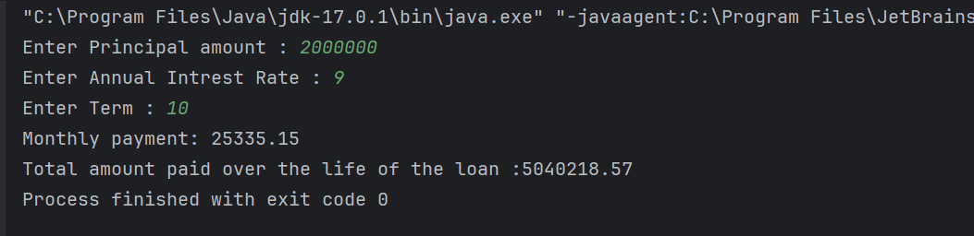

**2. Compound Interest Calculator for Investment**

Code:

**import java.util.Scanner;  
  
class CompoundInterestCalculator{  
 double p;  
 double r;  
 int n;  
 int t;  
  
 void acceptRedord(){  
 Scanner sc = new Scanner(System.*in*);  
 System.*out*.print("Enter Principal amount : ");  
 this.p = sc.nextDouble();  
 System.*out*.print("Enter Annual Intrest Rate : ");  
 this.r = sc.nextDouble();  
 System.*out*.print("Number of times the interest is compounded per year : ");  
 this.t = sc.nextInt();  
 System.*out*.print("Enter Term : ");  
 this.n = sc.nextInt();  
  
 }  
  
 void calculateFutureValue(){  
  
 double amount = p * Math.*pow*((1 + (r/100) / t), n * t);  
 double intrestEarned = amount - p;  
  
 System.*out*.printf("Total value after "+n+" years : %.2f \n",amount);  
 System.*out*.printf("Intrest earned : %.2f",intrestEarned);  
 }  
}  
  
public class Q2 {  
 public static void main(String[] args) {  
 CompoundInterestCalculator calc = new CompoundInterestCalculator();  
 calc.acceptRedord();  
 calc.calculateFutureValue();  
 }  
}**

**Output:**

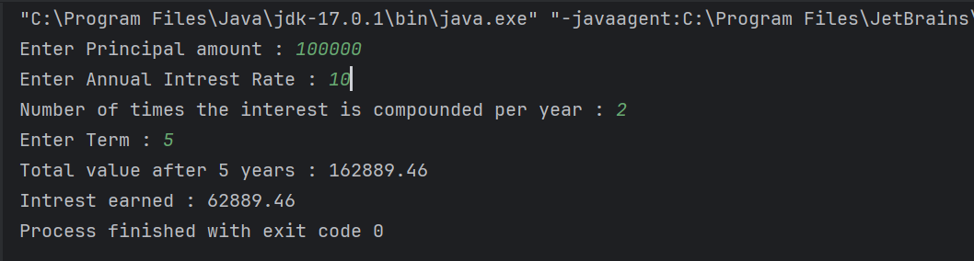

1. **BMI (Body Mass Index) Tracker**

**Code:**

**import java.util.Scanner;  
  
class Bmitracker{  
 float height;  
 float weight;  
 float BMI;  
 void acceptRecord(){  
 Scanner sc = new Scanner(System.*in*);  
 System.*out*.print("Enter height (in meter): ");  
 this.height = sc.nextFloat();  
 System.*out*.print("Enter weight (in Kg): ");  
 this.weight = sc.nextFloat();  
 }  
  
  
 void calculateBMI(){  
 this.BMI = weight/(height*height);  
 System.*out*.println("BMI: " + this.BMI);  
 if (BMI < 18.5) {  
 System.*out*.println("Result: UnderWeight");  
 } else if (BMI >= 18.5 && BMI <= 24.9) {  
 System.*out*.println("Result: Normal Weight");  
 } else if (BMI >= 25 && BMI <= 29.9) {  
 System.*out*.println("Result: Overweight");  
 }else{  
 System.*out*.println("Result: Obesity");  
 }  
 }  
  
  
}  
  
public class Q3 {  
 public static void main(String[] args) {  
 Bmitracker track = new Bmitracker();  
 track.acceptRecord();  
 track.calculateBMI();  
 }  
}**

**Output:**

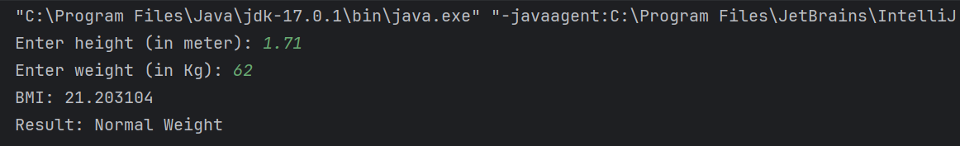

**4. Discount Calculation for Retail Sales**

**Code:**

**import java.util.Scanner;  
  
class DiscountCalculator{  
 double price;  
 double discount;  
 double discounted;  
 double finalprice;  
 void acceptRecord(){  
 Scanner sc = new Scanner(System.*in*);  
 System.*out*.print("Enter Price: ");  
 this.price = sc.nextDouble();  
 System.*out*.print("Enter discount %: ");  
 this.discount = sc.nextDouble();  
 }  
  
 void calculateDiscount(){  
 discounted = (price / 100)*discount;  
 finalprice = price - discounted;  
  
 }  
  
 void printRecord(){  
 System.*out*.printf("Discount: %.2f \n",discounted);  
 System.*out*.printf("Final Amount: %.2f",finalprice);  
 }  
  
}  
  
public class Q4 {  
 public static void main(String[] args) {  
 DiscountCalculator cal = new DiscountCalculator();  
 cal.acceptRecord();  
 cal.calculateDiscount();  
 cal.printRecord();  
 }  
}**

**Output:**

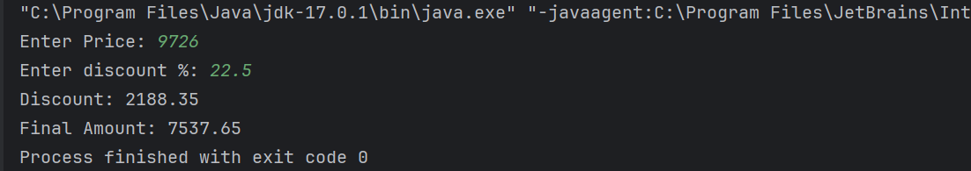

**5. Toll Booth Revenue Management**

**Code:**

**import java.util.Scanner;  
  
class TolBooth{  
 int car;  
 double carRate;  
 int truck;  
 double truckRate;  
 int bus;  
 double busRate;  
 int bike;  
 double bikeRate;  
 int auto;  
 double autoRate;  
 int totalVehicles;  
 void setTollRates(){  
 Scanner sc = new Scanner(System.*in*);  
 System.*out*.print("Set Tool for car: ");  
 this.carRate = sc.nextDouble();  
 System.*out*.print("Set Tool for Truck: ");  
 this.truckRate = sc.nextDouble();  
 System.*out*.print("Set Tool for Bus: ");  
 this.busRate = sc.nextDouble();  
 System.*out*.print("Set Tool for Bike: ");  
 this.bikeRate = sc.nextDouble();  
 System.*out*.print("Set Tool for Auto: ");  
 this.autoRate = sc.nextDouble();  
  
  
 }  
  
 void acceptRecord(){  
 Scanner sc = new Scanner(System.*in*);  
 System.*out*.println("Enter Details Below :");  
  
 System.*out*.println("Number of cars passed: ");  
 this.car = sc.nextInt();  
 this.totalVehicles+= this.car;  
 System.*out*.println("Number of trucks passed: ");  
 this.truck = sc.nextInt();  
 this.totalVehicles+= this.truck;  
 System.*out*.println("Number of bus passed: ");  
 this.bus = sc.nextInt();  
 this.totalVehicles+= this.bus;  
 System.*out*.println("Number of bikes passed: ");  
 this.bike = sc.nextInt();  
 this.totalVehicles+= this.bike;  
 System.*out*.println("Number of auto passed: ");  
 this.auto = sc.nextInt();  
 this.totalVehicles+= this.auto;  
  
 }  
  
 void calcRevenue(){  
 double totalRevenue = (car*carRate)+(truck*truckRate)+(bus*busRate)+  
 (bike*bikeRate)+(auto*autoRate);  
  
 System.*out*.println("Total Vehicles Passed: "+ this.totalVehicles);  
 System.*out*.printf("Total Revenue Generated: %.2f" , totalRevenue);  
 }  
}  
  
  
public class Q5 {  
 public static void main(String[] args) {  
 TolBooth toll = new TolBooth();  
 toll.setTollRates();  
 toll.acceptRecord();  
 toll.calcRevenue();  
 }  
}**

Output:

